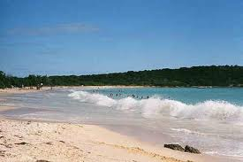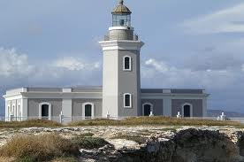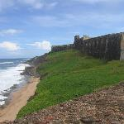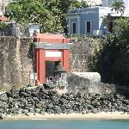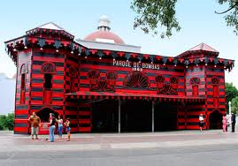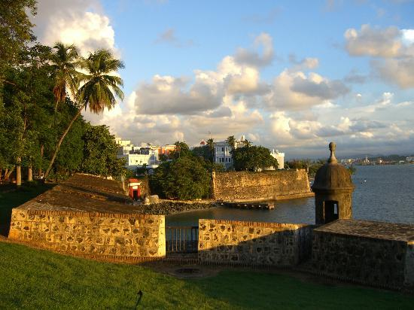

* Playa Sucia is one of the world's most beautiful beaches, and the main attraction for this city.
* El Farro Los Morrillos is a large lighthouse sitting atop the cliff of the Playa Sucia beach.

#### This town is called the 'Capital of Tourism' because of its beautiful beaches and wildlife reserves.

Cabo Rojo

* The Museo de Arte de Ponce has an internationally renowned collection comprised of more than 5,000 works of art from various cultures, creating a unique dialogue between the Old and New Worlds.
* High atop a hill overlooking Ponce, Serralles Castle, with its indoor patio, fountains and formal gardens, is the former home of a powerful rum and sugar cane baron.

## Ponce

* Old San Juan has many restored buildings from the 16th and 17th Spanish Colonial era.
* Castillo de San Cristobal is a massive 27-acre series of fortifications is the largest the Spanish built in the New World.
* When the San Juan Gate was built 4 centuries ago, it was the main gate to the city.

#### Known for its unique architectural designs, this city isn't called 'Pearl of the South' for nothing.

#### The oldest city on US territory, San Juan offers multiple things to do during your stay.

# San Juan

##### Mauris semper nibh ac felis?

Curabitur et lectus eget lectus ultrices feugiat. Pellentesque habitant morbi tristique senectus et netus et malesuada fames ac turpis egestas. Pellentesque pulvinar fermentum leo. Praesent aliquam, sapien eu suscipit gravida, magna tellus pretium sapien, ut adipiscing diam lectus et urna.

##### Vivamus nunc?

Proin eu sapien a ligula luctus mattis. Nam at dui a mauris vulputate ultrices. Pellentesque odio orci, egestas at, ultricies non, sollicitudin eget, magna. Curabitur scelerisque mollis turpis. Aliquam a purus. Fusce nec enim et magna facilisis feugiat.

##### Morbi euismod?

Mauris tempor. Aliquam scelerisque. Nam ligula nunc, rhoncus in, rhoncus at, elementum eget, eros. Lorem ipsum dolor sit amet, consectetuer adipiscing elit.

##### Nunc consequat mauris?

Duis mattis urna malesuada ipsum. Nulla orci tortor, commodo sit amet, sodales a, hendrerit sed, massa. Proin imperdiet, nisi ac molestie facilisis, sapien nibh consequat magna, ut hendrerit odio eros vel ante.

Aliquam enim lacus, consequat eu, porttitor quis, tincidunt vitae, quam. Vestibulum ante ipsum primis in faucibus orci luctus et ultrices posuere cubilia Curae; Nulla facilisi. Nulla mollis erat non lectus. Ut adipiscing porta est. Donec ut lectus vel odio venenatis ultrices. Pellentesque habitant morbi tristique senectus et netus et malesuada fames ac turpis egestas. Mauris nec dolor. Donec congue urna blandit nulla.

Cras nec quam vitae augue gravida tristique. Cras arcu quam, bibendum sed, tincidunt at, suscipit ut, neque. Pellentesque tellus tellus, nonummy ac, auctor in, nonummy id, nisi. Nam nisi ante, varius quis, porta ac, rhoncus sed, mi. Proin tempus est rhoncus risus. Nullam dolor ipsum, posuere at, suscipit varius, accumsan at, enim.

Suspendisse ac neque. Cum sociis natoque penatibus et magnis dis parturient montes, nascetur ridiculus mus. Donec sed turpis ornare nisl commodo cursus. Curabitur vehicula gravida magna. Morbi luctus. Nam gravida cursus turpis.

Donec risus lectus, auctor non, pretium eu, volutpat ac, ipsum. In hac habitasse platea dictumst. Mauris vitae dui. Curabitur feugiat, eros nec posuere iaculis, nunc augue pharetra nunc, quis interdum libero risus eu orci. Aenean tempor gravida orci. Sed et est. Nunc massa urna, mollis vitae, viverra ac, vulputate id, dolor. Pellentesque rhoncus pede eu sapien.

Nullam felis velit, fermentum in, vestibulum eu, fermentum quis, risus. Quisque sollicitudin. Curabitur suscipit massa ut pede.

# Aliquam consectetuer posuere lorem.

## Q&A